SOCIAL SCIENCE : CHAPTER 9
FAMILY AND COMMUNITY

What is a Family?
- A family is a group of people who are related to each other.
- They live together and care for one another.
- A family provides love, support, and protection.

Family Tree
- A family tree shows how family members are related to each other.
- It starts with grandparents at the top, then parents, and then children.
- It helps us know about our ancestors and relatives
Onam
- Onam is a major festival of Kerala.
- Celebrated to welcome King Mahabali, who is believed to visit Kerala during Onam.
- People make floral designs (Pookalam), wear new clothes, and prepare special food called Onasadya.
- It shows the joy and togetherness of the community and family.

Role of Members in a Family
Every family member has a role and responsibility:
  - Parents: Earn, guide, and take care of children.
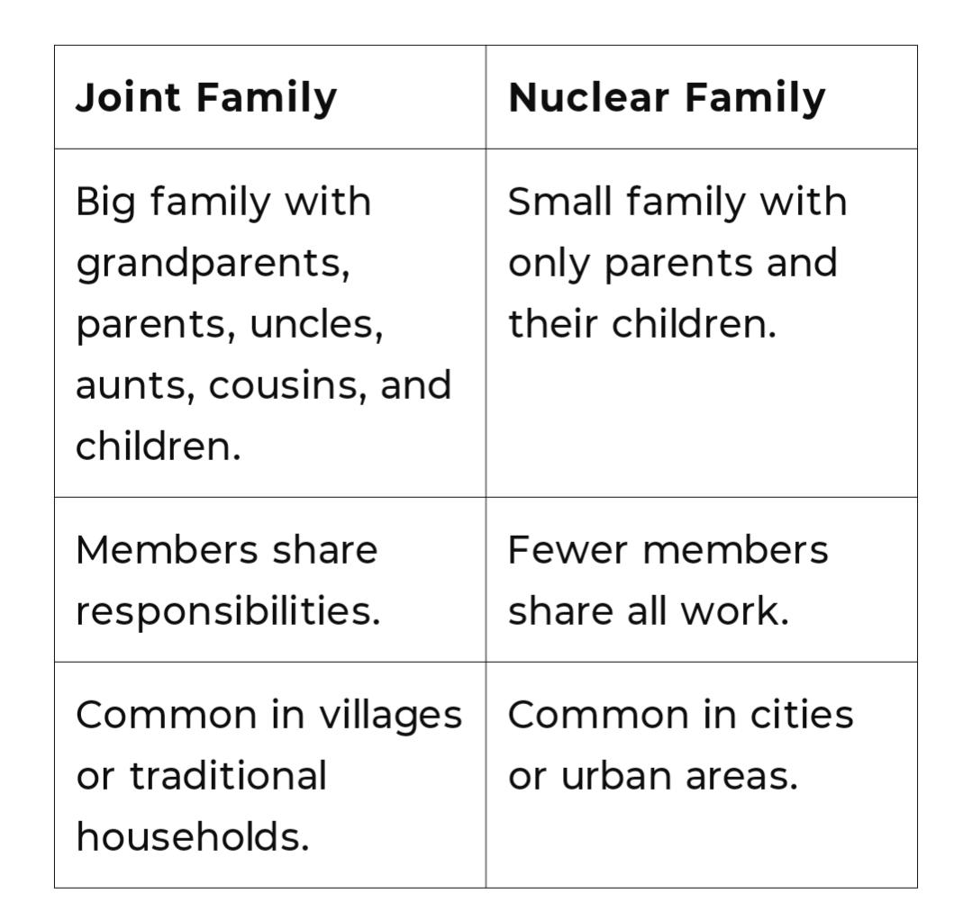
  - Children: Help in small tasks, study, and respect elders
  - Grandparents: Share wisdom, tell stories, and provide love.
  - Working together helps the family stay strong and happy.

What is a Community?
- A community is a group of people who live together in the same area and share common interests, culture, or goals.
- Examples: School community, neighborhood, village or town.
- People in a community help each other and work for the common good.
Joint Family and Nuclear Family

Joint Family

Advantages:
- Emotional Support: Strong family bonding due to shared responsibilities and time.
- Shared Responsibilities: Workload (household chores, child care) is divided among many.
- Financial Stability: Shared income and expenses reduce financial burden on individuals.
- Cultural Values: Better transmission of traditions, values, and customs to younger generations.
- Elder Care: Elderly members receive better care and attention.

Disadvantages:
- Lack of Privacy: Personal space may be limited due to many members living together.
- Conflicts: Differences in opinions or lifestyles may lead to arguments or misunderstandings.
- Decision-Making Issues: Individual choices may be influenced or restricted by others.
- Dependency: Some members may become overly dependent on others for support.

Nuclear Family

Advantages:
- Privacy and Independence: Members enjoy more freedom and personal space.
- Quick Decision-Making: Fewer people means faster and simpler decision-making.
- Less Conflict: Reduced chances of disputes due to fewer family members.
- Better Financial Control: Each unit manages its own finances independently.

Disadvantages:
- Lack of Support: Less emotional and physical support during crises or emergencies.
- Increased Responsibility: Parents must handle all household and parenting duties alone.
- Loneliness: Elderly or children may feel isolated due to fewer family interactions.
- Weaker Cultural Transmission: Less exposure to extended family can affect knowledge of traditions.

Multiple Choice Questions (MCQs):
- What kind of work does Tenzing's mother do?
a) She teaches at a local school
b) She runs a grocery shop
c) She works in a handicraft cooperative
d) She is a tourist guide
- How does Tenzing's grandfather help during emergencies in the colony?
a) He calls the police
b) He registers complaints and collects help from neighbours
c) He fixes power lines himself
d) He asks the government for money
- What does Tenzing’s family do when there are special expenses?
a) They take a loan from the bank
b) Only the father decides what to do
c) They discuss together as a family
d) They avoid spending any money

- Why did Shalini's parents decide to buy clothes for Chittappa, Chitti, and Chinni during the festival shopping?
a)Because they were obligated to
b)Because Acchamma forced them to
c)Because they wanted to support family members during financial hardship
d)Because they had extra money to spend
- What does the story mainly teach about family values?
a)Festivals are meant for shopping and celebrations
b) Only parents can make financial decisions
c)Family members should focus on their own needs first
d)Families support each other and share during tough times
- The local park is overgrown with weeds. What can you do to help your community?
(a) Ignore the problem
(b) Organise a Neighbourhood clean-up day
(c) Vandalise the park equipment
(d) Complain to everyone but take no action
7.Which of the following is an important principle of Indian culture that is taught in a family?
(a) Following one’s own desires
(b) Ignoring duties and responsibilities
(c) Following our dharma or doing our duty
(d) Avoiding sacrifices and service
8.Which of the following can be the possible reasons behind the interdependence of the communities?
I. Because they are self-sufficient
II. Because they have no relation with each other
III. Because they depend on each other for different works
IV. Because they are isolated from each other
Which of the above statements is/are incorrect?
(a) I, II and III only
(b) III only
(c) I, II and IV only
(d) I, II, III and IV
9.Assertion (A) Communities have rules regarding the use of shared natural wealth.
Reason (R) These rules are meant to restrict access to resources for communities.
Codes
(a) Both A and R are true and R is the correct explanation of A
(b) Both A and R are true, but R is not the correct explanation of A
(c) A is false, but R is true
(d) A is true, but R is false

10.Assertion (A) Joint families are common in Indian society.
Reason (R) Joint families allow for a sense of community and shared responsibilities among extended family members.
Codes
(a) Both A and R are true and R is the correct explanation of A
(b) Both A and R are true, but R is not the correct explanation of A
(c) A is false, but R is true
(d) A is true, but R is false

Subjective Application-Based Questions:
- What values can you learn from the way Tenzing’s family members share household responsibilities? Explain with examples from the story.

- How does the story reflect the importance of financial planning and community cooperation in daily life? Support your answer with two examples from the story.

